**INVENTORY MANAGEMENT SQL PROJECT**

--- Creating Database

CREATE DATABASE INVENTORY

-- Entering into the data base

USE INVENTORY

---***** CREATING TABLE SUPPLIER AND APPLYING CONSTRINTS ****

CREATE TABLE SUPPLIER

(SID CHAR(5) PRIMARY KEY,

SNAME VARCHAR(20) NOT NULL,

SADDRESS VARCHAR(50) NOT NULL,

SCITY VARCHAR(20) DEFAULT 'DELHI',

SPHONE CHAR(10) UNIQUE,

EMAIL VARCHAR(50));

------------------------------------------------

---**** CREATING TABLE PRODUCT AND APPLYING CONSTRINTS ****

CREATE TABLE PRODUCT

(PID CHAR(5) PRIMARY KEY,

PDESC VARCHAR(50) NOT NULL,

PRICE INT CHECK(PRICE>0),

CATEGORY CHAR(2) CHECK(CATEGORY = 'IT' OR CATEGORY = 'HR' OR CATEGORY = 'HC'),

SID CHAR(5) FOREIGN KEY REFERENCES SUPPLIER(SID));

-------------------------------------------------------

---*** CREATE TABLE STOCK & APPLYING CONSTRAINTS ***

CREATE TABLE STOCK

(PID CHAR(5) FOREIGN KEY REFERENCES PRODUCT(PID),

SQTY INT CHECK(SQTY>=0),

ROL INT CHECK(ROL>10),---Reorder level

MOQ INT CHECK (MOQ>=5))--- Minimum order quantity

--*** CREATE CUSTOMER TABLE APPLYING CONSTRAINTS ****

CREATE TABLE CUSTOMER

(CID CHAR(5) PRIMARY KEY,

CNAME VARCHAR(20) NOT NULL,

ADDRESS VARCHAR(20) NOT NULL,

CITY VARCHAR(10) NOT NULL,

PHONE CHAR(10) NOT NULL,

EMAIL VARCHAR(50) NOT NULL,

DOB DATE CHECK(DOB>'01-JAN-2000'));

---*** CREATE TABLE ORDERS AND APPLYING CONSTRAINTS ****

CREATE TABLE ORDERS

(OID CHAR(5) PRIMARY KEY,

ODATE DATE,

PID CHAR(5) FOREIGN KEY REFERENCES PRODUCT(PID),

CID CHAR(5) FOREIGN KEY REFERENCES CUSTOMER(CID));

----**** INSERTING DATA INTO TABLES *******

INSERT INTO SUPPLIER

VALUES('S0001','ABILASH','2-90 SRINAGAR','DELHI','9023092332','abilash22@gmail.com'),

('S0002','SRIRAM','3-2 CHANDNAGAR','DELHI','9000092332','sriram@gmail.com');

INSERT INTO SUPPLIER

VALUES('S0003','ANIL KUMAR','1-98 CITYROAD','DELHI','9023123332','anil56@gmail.com'),

('S0004','POORNA','3-2 AGRA','DELHI','9236092332','poorna@gmail.com'),

('S0005','SANTHOSH KUMAR','23-5 UTTHAMNAGAR','DELHI','9016235698','santhosh@gmail.com'),

('S0006','ANJALI','2-98 UTTHAMNAGAR','DELHI','9018963256','anjali@gmail.com'),

('S0007','DHANUSH CHANDHRA','23-5 MAIN ROAD','DELHI','9856235698','dhanush@gmail.com'),

('S0008','SARALA','2-01 M ROAD','DELHI','9016238998','sarala@gmail.com'),

('S0009','KIRAN KUMAR','1-11 METRO NAGAR','DELHI','9015687698','kiran99@gmail.com'),

('S0010','UPENDHAR','89-66 SMART BAZAR','DELHI','9016235620','upendhar@gmail.com');

---- FETCHING DATA FROM SUPPLIER TABLE

SELECT * FROM SUPPLIER

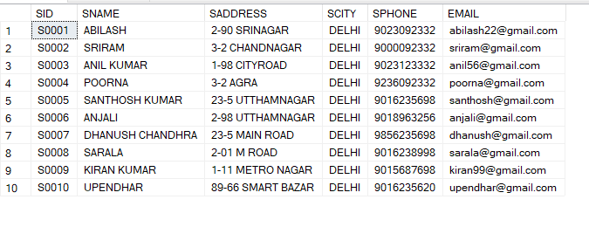

----*** INSERTING DATA INTO PRODUCT TABLE *****

INSERT INTO PRODUCT

VALUES('P0001' ,'Mouse Intel pro','1500','IT','S0001'),

('P0002',' Laptop Inter celeron 3205U','50000','IT','S0001'),

('P0003',' keyboard Intel Pro 99','1000','IT','S0001'),

('P0004','printer intel','15000','IT','S0001'),

('P0005','Scanner intel pro','10000','IT','S0001'),

('P0006','Sanitizer','1000','HC','S0002'),

('P0007','Mask','1200','HC','S0002'),

('P0008','Syringes','1450','HC','S0003'),

('P0009','Needles','2000','HC','S0004'),

('P0010','Microwave philiphs','20000','HA','S0003'),

('P0011','Kettle','3000','HA','S0004'),

('P0012','Wahing Machine Panasonic','20000','HA','S0005'),

('P0013','Grinder','6000','HA','S0006'),

('P0014','Television','21000','HA','S0010'),

('P0015','Rice Cooker','6000','HA','S0009');

---FETCHING DATA FROM PRODUCT TABLE

SELECT * FROM PRODUCT

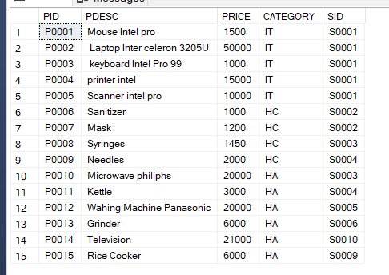

---*** INSERTING DATA INTO STOCK TABLE ****

INSERT INTO STOCK

VALUES('P0001','20','11','10')

INSERT INTO STOCK

VALUES('P0002','30','11','10'),

('P0003','15','12','10'),

('P0004','12','15','10'),

('P0005','100','12','10'),

('P0006','50','11','5'),

('P0006','20','11','5'),

('P0007','25','11','5'),

('P0008','25','11','5'),

('P0009','23','11','5'),

('P0010','25','11','5');

--- FETCH DATA FROM STOCK TABLE

SELECT * FROM STOCK

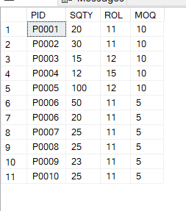

----INSERTING DATA INTO CUSTOMER TABLE

INSERT INTO CUSTOMER

VALUES('C0001','SARATH KUMAR','AMEERPET','HYD','9236987545','sarath@gmail.com','01-JUL-1989'),

('C0002','RAMESH','HITECH CITY','HYD','9237887545','ramesh@gmail.com','11-AUG-1989'),

('C0003','ANITHA','X ROAD','CHENNAI','9236987578','anitha@gmail.com','21-JUN-1999'),

('C0004','SARATH','AMEERPET','HYD','9236987545','sarath@gmail.com','01-SEP-1986'),

('C0005','SRAVAN KUMAR','RG ROAD','BENGOLORE','8936987545','sravan@gmail.com','21-APR-1989'),

('C0006','RAMYA','SH ROAD','CHENNAI','8975987545','ramya@gmail.com','23-JUL-1985'),

('C0007','SAARA','KPHB','HYD','9236987545','saara@gmail.com','01-JUN-1987'),

('C0008','ANAND','JNTU','HYD','9236987540','anand@gmail.com','01-JUN-1989'),

('C0009','MAHESH','SR NAGAR','HYD','9236087545','maheh@gmail.com','01-OCT-1987'),

('C0010','GURUNATH','NEAR METRO STATION','HYD','9230987545','gurunath@gmail.com','01-FEB-1999'),

('C0011','SOWMYA','CROSS ROAD','HYD','9206987545','sowmya@gmail.com','11-JUL-1984');

---*** FETCHING DATA FROM CUSTOMER TABLE***

SELECT * FROM CUSTOMER

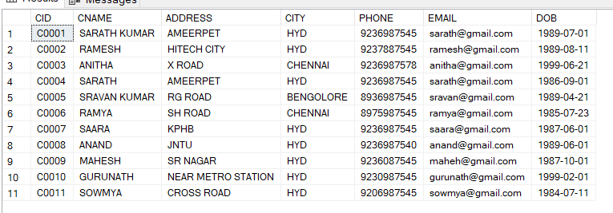

---- INSERTING DATA INTO ORDERS TABLE

INSERT INTO ORDERS

VALUES('O0001','12-JAN-2023','P0001','C0001','1'),

('O0002','02-JUL-2023','P0002','C0002','1'),

('O0003','12-MAY-2023','P0003','C0003','1'),

('O0004','12-OCT-2023','P0004','C0004','1'),

('O0005','22-DEC-2023','P0005','C0005','50'),

('O0006','25-FEB-2023','P0006','C0006','10'),

('O0007','12-JUL-2023','P0005','C0007','10');

---- FETCHING DATA FROM ORDERS TABLE

SELECT * FROM ORDERS

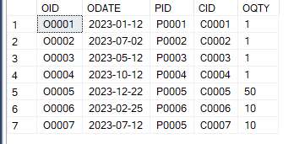

--- CREATING VIEW

CREATE VIEW BILL

AS

SELECT O.OID,O.ODATE,O.OQTY ,C.CNAME,C.ADDRESS,C.PHONE,P.PDESC,P.PRICE, O.OQTY * P.PRICE AS AMOUNT

FROM CUSTOMER C

JOIN

ORDERS O

ON C.CID = O.CID

JOIN

PRODUCT P

ON O.PID = P.PID

SELECT * FROM BILL

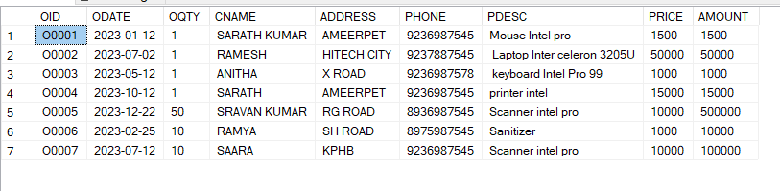

/* create procedure - name given to a pre wriiten code,stored procedure is prepared sql code that we save so we can re use

over and over again instead of writing query each time*/

--By using procedure inserting data into tables

SELECT * FROM SUPPLIER

CREATE PROCEDURE ADDSUPPLIER

@SID as CHAR(5),@SNAME as VARCHAR(20),@SADDRESS as VARCHAR(50),@SCITY as VARCHAR(20),@SPHONE CHAR(10),@EMAIL VARCHAR(50)

AS

BEGIN

SET NOCOUNT ON

INSERT INTO SUPPLIER

VALUES(@SID,@SNAME,@SADDRESS,@SCITY,@SPHONE,@EMAIL)

END;

ADDSUPPLIER'S0011','VIKRANTH REDDY','X-ROAD','MUMBAI','9875463698','vikranth@gmail.com'

ADDSUPPLIER'S0012','RAAJEEV','MSR-ROAD','KOLKATHA','8975463698','raajeev@gmail.com'

SELECT * FROM SUPPLIER

------------------------------------------------------------------------------

SELECT * FROM PRODUCT

CREATE PROCEDURE ADDPRO

@PID as CHAR(5),@PDSC as VARCHAR(50),@PRICE as INT,@CATEGORY as CHAR(2),@SID AS CHAR(5)

AS

BEGIN

SET NOCOUNT ON

INSERT INTO PRODUCT

VALUES(@PID,@PDSC,@PRICE,@CATEGORY,@SID)

END;

ADDPRO'P0016','JUICER',1000,'HA','S0009'

ADDPRO'P0017','BLENDER',800,'HA','S0009'

ADDPRO'P0018','MEDICINE',8000,'HC','S0001'

ADDPRO'P0019','MOBILE',1000,'IT','S0007'

ADDPRO'P0020','FAN',1000,'HA','S0010'

---------------------------------------------------

SELECT * FROM CUSTOMER

CREATE PROCEDURE ADDCUST

@CID as CHAR(5),@CNAME as VARCHAR(20),@ADDRESS as VARCHAR(20),@CITY as VARCHAR(10),@PHONE as CHAR(10),@EMAIL VARCHAR(50),@DOB as DATE

AS

BEGIN

SET NOCOUNT ON

INSERT INTO CUSTOMER

VALUES(@CID,@CNAME,@ADDRESS,@CITY,@PHONE,@EMAIL,@DOB)

END;

ADDCUST'C0012','VIKRANTH REDDY','HITECH CITY','MUMBAI','7575463698','vikranth@gmail.com','12-jan-1998';

ADDCUST'C0013','SARANYA','BANZARA HILLS','HYD','9075463698','saranya@gmail.com','15-mar-1987';

ADDCUST'C0014','RAGHU RAM','HITECH CITY','MUMBAI','7570063698','raghu@gmail.com','12-oct-1998';

ADDCUST'C0015','SUNEETHA RANI','BANZARA HILLS','HYDERBAD','9075463692','suneetha@gmail.com','12-mar-1984';

---------------------------------------------------------------------------------------------

SELECT * FROM ORDERS

CREATE PROCEDURE ADDORDER

@OID as CHAR(5),@ODATE as DATE,@PID as CHAR(5),@CID as CHAR(5),@OQTY AS INT

AS

BEGIN

SET NOCOUNT ON

INSERT INTO ORDERS(OID,ODATE,PID,CID,OQTY)

VALUES(@OID,GETDATE(),@PID,@CID,@OQTY)

END;

---DROP PROCEDURE ADDORDER

/*INSERTING DATA BY USING PROCEDURE*/

ADDORDER'O0008','','P0001','C0002','5'

ADDORDER'O0009','','P0002','C0003','15'

/* DROPPING PROCEDURES*/

DROP PROCEDURE ADDSUPPLIER

DROP PROCEDURE ADDPRO

DROP PROCEDURE ADDCUST

DROP PROCEDURE ADDORDER

--USING FUNCTIONS AND PROCEDURES FOR INSERTING DATA INTO TABLES---

----------------------------------------------------------------------

/* function for creating SID*/

CREATE FUNCTION GenerateSID()

RETURNS CHAR(5)

AS

BEGIN

DECLARE @NewID CHAR(5);

-- Generate new SID

SELECT @NewID = RIGHT('S' + RIGHT('0000' + CAST(ISNULL(MAX(CAST(SUBSTRING(SID, 2, 5) AS INT)), 0) + 1 AS VARCHAR(5)), 4), 5)

FROM SUPPLIER;

RETURN @NewID;

END;

/* function for creating PID*/

DROP FUNCTION GeneratePID

CREATE FUNCTION GeneratePID()

RETURNS CHAR(5)

AS

BEGIN

DECLARE @NewID CHAR(5);

-- Generate new PID

SELECT @NewID = RIGHT('P' + RIGHT('0000' + CAST(ISNULL(MAX(CAST(SUBSTRING(PID, 2, 5) AS INT)), 0) + 1 AS VARCHAR(5)), 4), 5)

FROM PRODUCT;

RETURN @NewID;

END;

/* function for creating CID*/

CREATE FUNCTION GenerateCID()

RETURNS CHAR(5)

AS

BEGIN

DECLARE @NewID CHAR(5);

-- Generate new CID

SELECT @NewID = RIGHT('C' + RIGHT('0000' + CAST(ISNULL(MAX(CAST(SUBSTRING(CID, 2, 5) AS INT)), 0) + 1 AS VARCHAR(5)), 4), 5)

FROM CUSTOMER;

RETURN @NewID;

END;

/* function for creating OID*/

CREATE FUNCTION GenerateOID()

RETURNS CHAR(5)

AS

BEGIN

DECLARE @NewID CHAR(5);

-- Generate new OID

SELECT @NewID = RIGHT('O' + RIGHT('0000' + CAST(ISNULL(MAX(CAST(SUBSTRING(OID, 2, 5) AS INT)), 0) + 1 AS VARCHAR(5)), 4), 5)

FROM ORDERS;

RETURN @NewID;

END;

-------------------------------------------------------------------------

DROP PROCEDURE ADDSUPPLIER

CREATE PROCEDURE ADDSUPPLIER

@SNAME VARCHAR(20),

@SADDRESS VARCHAR(50),

@SCITY VARCHAR(20) = 'DELHI',

@SPHONE CHAR(10),

@EMAIL VARCHAR(50)

AS

BEGIN

SET NOCOUNT ON;

DECLARE @SID CHAR(5) = dbo.GenerateSID();

INSERT INTO SUPPLIER (SID, SNAME, SADDRESS, SCITY, SPHONE, EMAIL)

VALUES (@SID, @SNAME, @SADDRESS, @SCITY, @SPHONE, @EMAIL);

END;

-- Usage

EXEC ADDSUPPLIER 'VIKAS REDDY', 'M-ROAD', 'PUNE', '9700044698', 'vikas@gmail.com';

EXEC ADDSUPPLIER 'SRIDHAR REDDY', 'MHS-CROSS ROAD', 'DELHI', '9701163698', 'sridhar@gmail.com';

-----------------------------------------------------------------------------------------

CREATE PROCEDURE ADDPRO

@PDSC VARCHAR(50),

@PRICE INT,

@CATEGORY CHAR(2),

@SID CHAR(5)

AS

BEGIN

SET NOCOUNT ON;

DECLARE @PID CHAR(5) = dbo.GeneratePID();

INSERT INTO PRODUCT (PID, PDESC, PRICE, CATEGORY, SID)

VALUES (@PID, @PDSC, @PRICE, @CATEGORY, @SID);

END;

-- Usage

EXEC ADDPRO 'COOKER', 1000, 'HA', 'S0009';

--------------------------------------------------------------------

CREATE PROCEDURE ADDCUST

@CNAME VARCHAR(20),

@ADDRESS VARCHAR(20),

@CITY VARCHAR(10),

@PHONE CHAR(10),

@EMAIL VARCHAR(50),

@DOB DATE

AS

BEGIN

SET NOCOUNT ON;

DECLARE @NewCID CHAR(5) = dbo.GenerateCID();

INSERT INTO CUSTOMER (CID, CNAME, ADDRESS, CITY, PHONE, EMAIL, DOB)

VALUES (@NewCID, @CNAME, @ADDRESS, @CITY, @PHONE, @EMAIL, @DOB);

END;

-- Usage example:

EXEC ADDCUST 'VIMALA', 'GMS CITY', 'MUMBAI', '7575463690', 'vimala@gmail.com', '1997-01-12';

-------------------------------------------------------------------

CREATE PROCEDURE ADDORDER

@CID CHAR(5),

@PID CHAR(5),

@OQTY INT

AS

BEGIN

SET NOCOUNT ON;

DECLARE @OID CHAR(5) = dbo.GenerateOID();

INSERT INTO ORDERS (OID, ODATE, PID, CID, OQTY)

VALUES (@OID, GETDATE(), @PID, @CID, @OQTY);

END;

-- Usage

EXEC ADDORDER 'C0002', 'P0001', 5;

EXEC ADDORDER 'C0002', 'P0001', 10;

SELECT * FROM SUPPLIER

SELECT * FROM PRODUCT

SELECT * FROM CUSTOMER

SELECT * FROM ORDERS

SELECT * FROM STOCK

----- TRIGGER

CREATE TRIGGER trg_UpdateStock

ON ORDERS

AFTER INSERT

AS

BEGIN

SET NOCOUNT ON;

UPDATE STOCK

SET SQTY = SQTY - i.OQTY

FROM STOCK s

INNER JOIN inserted i ON s.PID = i.PID

WHERE s.PID = i.PID;

END;